Helpdesk Installtion Doc

Step-1  
*Firstly you run this script*

itop script.sh

#!/bin/bash

# Step 1: Update System and Install MySQL server and client

echo "Updating system and installing MySQL server and client..."

export DEBIAN_FRONTEND=noninteractive

apt update && apt upgrade -y

apt install -y mysql-server mysql-client

# Step 2: Start MySQL service and secure installation

echo "Starting MySQL service..."

service mysql start

# Configure MySQL root password and create database/user

echo "Configuring MySQL database and user..."

mysql -u root <<MYSQL_SCRIPT

ALTER USER 'root'@'localhost' IDENTIFIED WITH mysql_native_password BY 'Root@123';

FLUSH PRIVILEGES;

CREATE DATABASE itop CHARACTER SET UTF8 COLLATE UTF8_BIN;

CREATE USER 'itop'@'%' IDENTIFIED BY 'Admin@123';

GRANT ALL PRIVILEGES ON itop.* TO 'itop'@'%';

FLUSH PRIVILEGES;

MYSQL_SCRIPT

# Step 3: Install Apache and PHP

echo "Installing Apache and PHP..."

apt install -y apache2 php libapache2-mod-php php-mysql php-ldap php-soap php-json php-mbstring php-curl php-xml php-gd php-dom php-zip php-apcu

# Step 4: Configure PHP settings

echo "Configuring PHP settings..."

PHP_INI=$(php --ini | grep "Loaded Configuration File:" | awk '{print $4}')

sed -i "s/upload_max_filesize = .*/upload_max_filesize = 32M/" $PHP_INI

sed -i "s/post_max_size = .*/post_max_size = 32M/" $PHP_INI

sed -i "s/memory_limit = .*/memory_limit = 256M/" $PHP_INI

sed -i "s/max_execution_time = .*/max_execution_time = 300/" $PHP_INI

sed -i "s/max_input_time = .*/max_input_time = 60/" $PHP_INI

sed -i "s/;max_input_vars = .*/max_input_vars = 4440/" $PHP_INI

sed -i "s/;date.timezone =.*/date.timezone = Asia\/Kolkata/" $PHP_INI

# Enable Apache overrides

echo "Enabling Apache AllowOverride..."

sed -i 's/AllowOverride None/AllowOverride All/' /etc/apache2/apache2.conf

systemctl restart apache2

# Restart Apache

echo "Restarting Apache service..."

service apache2 restart

# Step 5: Install iTop

echo "Installing iTop..."

apt install -y unzip software-properties-common

cd /tmp

wget https://sourceforge.net/projects/itop/files/latest/download -O itop.zip

unzip itop.zip

# Step 6: Move iTop to web directory

echo "Configuring iTop directory..."

mkdir -p /var/www/html/mctsm

mv /tmp/web/* /var/www/html/mctsm/

cd /var/www/html/mctsm

mkdir conf data env-production env-production-build log

chown -R www-data:www-data /var/www/html/mctsm/

# Step 7: Final instructions

echo "Installation complete. Please open your browser and navigate to http://192.168.100.170/mctsm to complete the setup."

echo "Database Configuration:"

echo "Server Name - localhost"

echo "Login - itop"

echo "Password - Admin@123"

echo "Follow the prompts to complete the iTop installation."

Step-2  
*After run script you can clone gitlab code on /var/www/html and delete mctsm dir or *default index.html* file.  
  
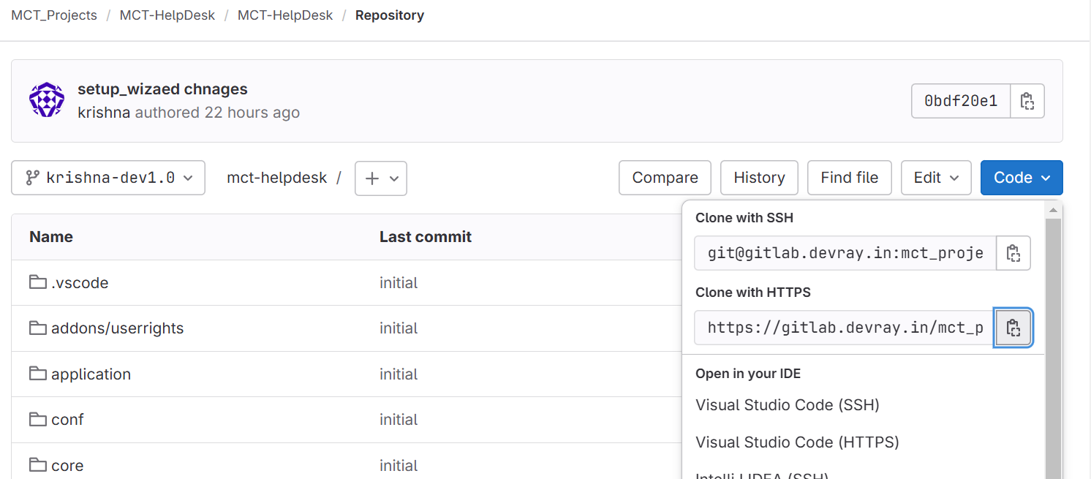  
  
<https://gitlab.devray.in/mct_projects/mct-helpdesk/mct-helpdesk.git>

Step-3  
*Change ownership permission and   
  
#sudo chown -R www-data:www-data /var/www/html/mct-helpdesk/  
#cd /etc/apache2/sites-available/  
  
#cat 000-default.conf  
  
ServerAdmin webmaster@localhost

DocumentRoot /var/www/html/mct-helpdesk

<Directory /var/www/html/mct-helpdesk>

Options Indexes FollowSymLinks

AllowOverride All

Require all granted

</Directory>  
  
#systemctl restart apache2  
#systemctl reload apache2